**Report**

## Problem Statement:

Java-Programmed Application for calculating the prime implicants (PI) and the essential prime implicants for any function by knowing the minterms and don’t-care terms of the function with any number of variables (n).

## Methodology:

1. Scanning number of variables from the user.
2. Scanning the minterms and don’t-care terms of the function.
3. Creating tabular table with minterms and don’t-care terms in the first column.
4. For every 3 columns; the first is the value of the term, the second is the summation of the excluded bits and the third explains if this term is prime implicant or not.
5. Filling tabular table using tabular method.
6. Extracting all the prime implicants including duplicates.
7. Removing the duplicates.
8. Creating PI table with prime implicants as the first column and minterms as the first row.
9. Marking the minterms covered by each PI.
10. Extracting the essential PI from each column including the duplicates.
11. Removing the duplicates.
12. Converting each essential term to its corresponding expression.
13. Printing the PI and essential PI to the user.

## Data Structures:

Only Multi-Dimensional Arrays are used (1-2D arrays).

## Sample Runs:

* Input: Number of variables: 4

m( 0 2 4 6 8 ) + d( 10 11 12 13 14 )

Output:

PIs are AC, AB, D’

Essential PIs are D’

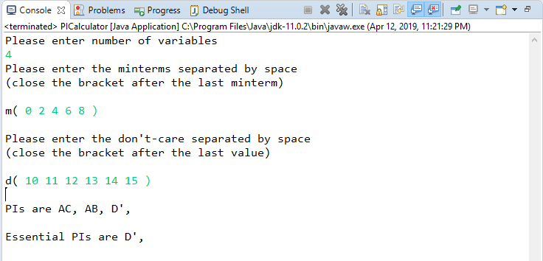

* Input: Number of variables: 4

m( 1 2 3 4 9 ) + d( 10 11 12 13 14 15 )

Output:

PIs are BC'D', B'D, B'C, AD, AC, AB

Essential PIs are B'D, B'C, BC'D'

